**PLANT DISEASE DETECTION USING MACHINE LEAERNING**

***Synopsis report of Major Project***

**BACHELOR OF TECHNOLOGY in INFORMATION TECHNOLOGY**

# Submitted by

|  |  |  |  |  |  |
| --- | --- | --- | --- | --- | --- |
| **Roll Number** | **Name** | **Year** | **Branch** | **Section** | **Outcome**  **(Patent/Research**  **Paper/**  **Application**  **Project deployable)** |
| **2100290130023** | AMAN SINGH | **3** | **IT** | **A** | **Research Paper** |
| **21002901300062** | **DEV PRATAP SINGH** | **3** | **IT** | **A** |  |
| **2100290130038** | ARPIT PAL | **3** | **IT** | A |  |
| **2100290130177** | **SUMIT CHAUDHARY** | **3** | **IT** | **C** |  |



# DEPARTMENT OF INFORMATION TECHNOLOGY

**KIET GROUP OF INSTITUTIONS, GHAZIABAD, UTTAR PARDESH**

**(Affiliated to Dr. A.P.J. Abdul Kalam Technical University, Lucknow, UP, India)**

**Odd Semester, Session 2023-24**

# ABSTRACT

Foliar diseases are common ailments that affect the leaves of various plants, often caused by fungal or fungal-like organisms. These diseases can have a significant impact on plant health and productivity, making accurate diagnosis crucial for timely treatment and prevention of yield losses. Traditional methods of disease identification rely on labor-intensive field scouting, which can be inefficient and time-consuming. To address this, our project focuses on utilizing deep learning techniques, specifically convolutional neural networks (CNNs), to classify and identify tree diseases. By employing various deep learning and machine learning methods, we aim to determine the most effective approach for disease classification. The project specifically focuses on identifying the most prevalent diseases found in tomato, potato, and pepper plants, encompassing a total of 15 different illnesses. By allowing users to upload leaf images, our system provides real-time disease detection and offers the name of the identified disease, along with recommended pesticides for treatment. In cases where no disease is detected, a message indicating the absence of disease is displayed. Additionally, the system provides information on the proportion of the affected area and suggests suitable pesticides based on the extent of damage. As part of the research, we conducted a survey of various classification methods applicable to plant leaf diseases. The ultimate goal of this project is to contribute to the development of an efficient and user-friendly tool that enables early disease detection, mitigates crop losses, and promotes overall plant health.

In this project, we developed a system for the detection of foliar diseases in tomato, potato, and pepper plants using machine learning and image processing techniques. The system aims to accurately identify and classify 15 different types of diseases based on uploaded leaf images. By analyzing the color information and employing classification algorithms, the system can provide real-time disease diagnosis and recommend appropriate pesticides for treatment. The system also estimates the proportion of affected areas and provides insights for crop management. Through the implementation of deep learning models and extensive dataset analysis,we achieved high accuracy in disease detection.

## INDRODUCTION

Plant diseases cause yield reductions that have a direct influence on the domestic and international food production systems and lead to financial losses. About 20% to 40% of the world's food output is lost due to plant diseases and pests, according to the FAO of the United Nations has reported that 13% of global crop yield losses are due to plant diseases. This highlights the importance of identifying and preventing plant diseases to minimize these losses. One method for identifying plant diseases is by analyzing images of plant leaves, using a technique called "image processing" which falls under the field of signal processing. By leveraging the power of artificial intelligence, specifically machine learning, we can extract meaningful information from these images to accurately detect and diagnose plant diseases and thinking performs tasks itself or provides instructions on how to carry them out. Understanding the training data and incorporating it into models that should be helpful to humans is the basic goal of machine learning. Thus, it may help in making wise selections and forecasting the right output utilizing the vast training data. Leaf color, leaf damage level, leaf area, and leaf texture characteristics are utilized for classification. Several forms of plant diseases damage various plant organs. Plant pathologists can most easily identify foliar diseases, which are plant diseases that manifest symptoms on leaves. Fungal diseases are a major cause of yield losses, accounting for up to 50% of the total losses. As a result, many researchers are using computer vision, machine learning, and deep learning techniques to detect and diagnose plant diseases using images of plant leaves. Effective diagnosis of plant diseases involves early detection of diseases, identifying multiple diseases in different crops, estimating the severity of the disease, determining the appropriate amount of pesticide to apply, and taking practical measures to manage the disease and prevent its spread.

## 

## MOTIVATION

The motivation behind the project to develop a system for the detection of foliar diseases in tomato, potato, and pepper plants using machine learning and image processing techniques is grounded in several crucial factors:

1.Impact on Plant Health and Productivity: Foliar diseases caused by fungal or fungal-like organisms significantly affect plant health and crop productivity. Accurate and timely diagnosis is imperative to prevent yield losses and maintain the overall health of plants.

2.Inefficiency of Traditional Methods: Traditional methods of disease identification, such as labor-intensive field scouting, are inefficient and time-consuming. This project seeks to address these shortcomings by leveraging technology to automate and streamline the diagnosis process.

3.Advancements in Deep Learning and Machine Learning: The utilization of deep learning techniques, specifically convolutional neural networks (CNNs), presents a promising opportunity to revolutionize disease identification in plants. Leveraging these advanced technologies can lead to more accurate and efficient diagnoses.

4.Need for Early Detection and Treatment: Early disease detection is crucial for effective treatment and mitigation of crop losses. Providing real-time disease detection through a user-friendly tool can enable farmers to take timely action, thereby reducing the impact of diseases on their crops.

5.Promotion of Plant Health: By developing an efficient and user-friendly tool for disease detection, the project aims to contribute to overall plant health. Empowering farmers with tools that assist in disease management and treatment recommendations promotes better crop health and yields.

6.Potential Impact on Agriculture: Improving disease detection and management in agriculture can have far-reaching implications, not only for individual farmers but also for agricultural practices on a larger scale. It can contribute to sustainable farming practices and food security.

## BACKGROUND

The background of the project involves addressing the challenges associated with foliar diseases in plants, particularly tomato, potato, and pepper plants. Foliar diseases, often caused by fungal or fungal-like organisms, can severely impact plant health and productivity, leading to significant yield losses if not promptly diagnosed and treated. The traditional methods of disease identification, relying on labor-intensive field scouting, are inefficient and time-consuming.

To overcome these challenges, the project leverages advanced technologies, specifically deep learning techniques, with a focus on convolutional neural networks (CNNs). The goal is to develop a robust system capable of classifying and identifying 15 different foliar diseases in tomato, potato, and pepper plants. This system allows users to upload leaf images, enabling real-time disease detection. In case of disease identification, the system provides the name of the disease along with recommended pesticides for treatment. If no disease is detected, a message indicating the absence of disease is displayed.

### 

### PLANNING OF PROJECT

**1. Project Definition and Scope**

* Clearly define the objectives and goals of the project.
* Specify the scope, including the targeted plants (tomato, potato, and pepper) and the number of diseases to be identified (15 in total).

**2. Literature Review**

* Conduct a comprehensive review of existing literature on foliar diseases in plants and their identification methods.
* Analyze relevant research papers, articles, and methodologies related to machine learning, deep learning, and image processing in plant disease detection.

**3. Data Collection and Preprocessing**

* Gather a diverse and representative dataset of leaf images for tomato, potato, and pepper plants, covering the 15 different diseases.
* Preprocess the images to enhance quality, resize them if necessary, and ensure uniformity in terms of lighting and background.

**4. Model Selection and Architecture**

* Choose appropriate deep learning models, with a focus on convolutional neural networks (CNNs) for image classification.
* Design the architecture of the chosen model(s) for optimal disease detection.

**5. Training and Validation**

* Split the dataset into training and validation sets.
* Train the chosen model(s) on the training set and fine-tune parameters for optimal performance.
* Validate the model(s) on the validation set to ensure generalization.

**6. Evaluation Metrics**

* Define metrics for evaluating the performance of your models, such as accuracy, precision, recall, and F1 score.
* Establish a baseline for comparison and set performance targets.

**7. Integration with User Interface**

* Develop a user-friendly interface for users to upload leaf images.
* Implement real-time disease detection and display the identified disease along with relevant information.

**8. Pesticide Recommendation System**

* Integrate a system for recommending appropriate pesticides based on the identified disease.
* Consider factors such as the severity of the disease and the affected area in the recommendation process.

**9. Testing and Validation**

* Conduct thorough testing of the entire system, including image upload, disease detection, and pesticide recommendation.
* Validate the accuracy and reliability of the system through testing with different datasets.

**10. Documentation**

* Document the entire development process, including data collection, preprocessing steps, model architecture, and system implementation.
* Provide clear instructions on how to use the system.

**11. Deployment**

* Prepare the system for deployment in a real-world environment.
* Consider scalability and potential integration with existing agricultural management systems.

**12. Continuous Improvement**

* Establish a plan for continuous improvement, including updates to the dataset, model retraining, and feedback mechanisms for users.

**13. Final Report and Presentation**

* Prepare a final report summarizing the project, its objectives, methodologies, findings, and future recommendations.
* Develop a presentation to communicate the key aspects of the project to stakeholders or a broader audience.

## GANTT CHART

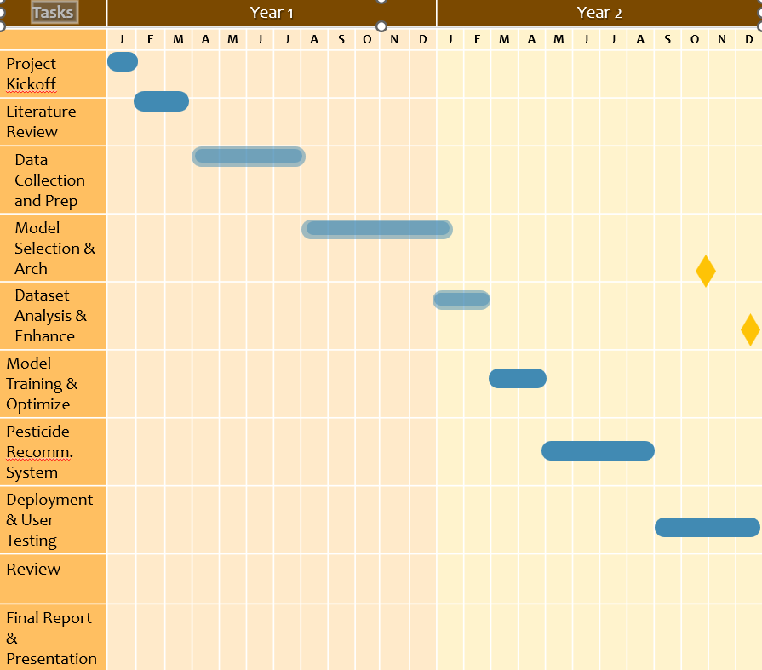

REFERENCES

*1.Literature Review of Diagnosis Rice Leaves Diseases Using Image Processing R.I.L.Jayasooriya, Samantha Mathara Arachchi University of Colombo School of Computing, 35, Reid Avenue, Colombo 7, Sri Lanka.*

*2.Plant Disease Detection Using Image Processing and Machine Learning Pranesh Kulkarni1,Atharva Karwande1,Tejas Kolhe1,Soham Kamble1,Akshay Joshi1,Medha Wyawahare1 1 Department of Electronics and Telecommunication,Vishwakarma Institute of Technology, Pune, India.*